PROJECT SUMMARY
Project Name: "Financial AI: Your Mentor and Investment Analyst"

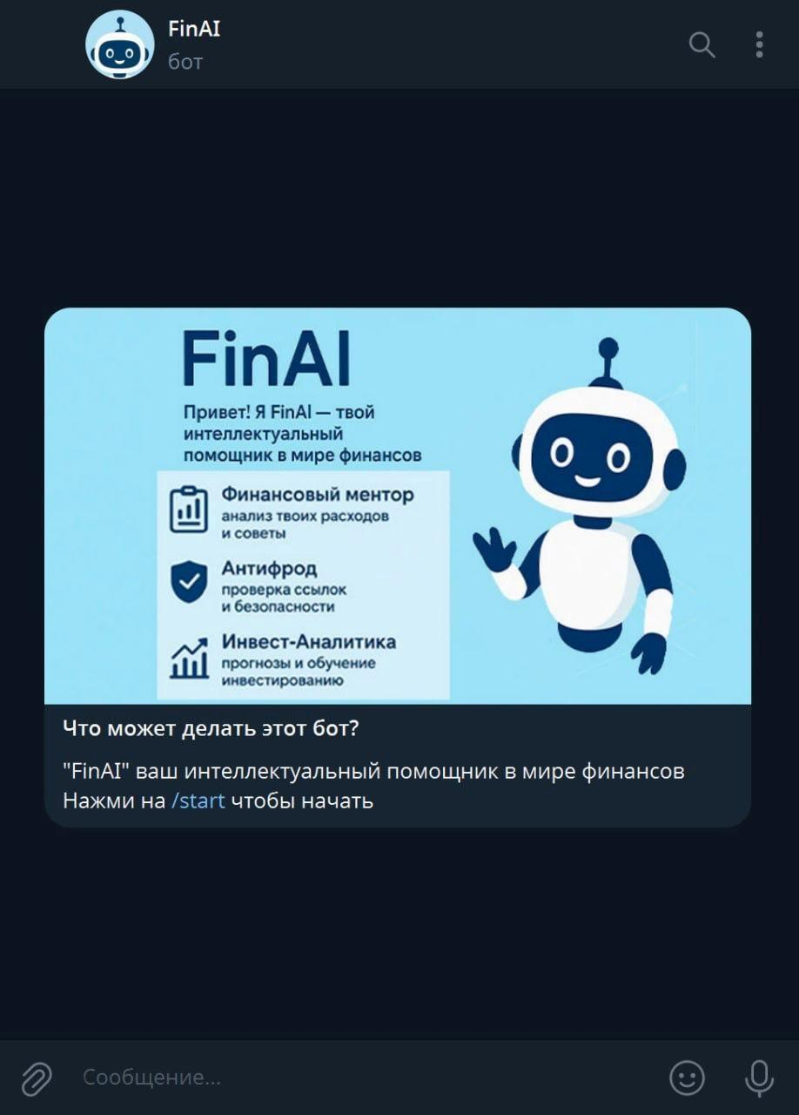

INTRODUCTION

In the modern world, artificial intelligence technologies are becoming increasingly integrated into daily life. The financial sector is one of the most sensitive and critical segments of the economy, where errors, a lack of awareness, or incompetence directly impact the well-being of citizens. Concurrently, the digitalization of the economy in Kazakhstan and the CIS countries is gaining momentum, and with it, the risks are growing—from cyber fraud to uninformed financial decisions.
The relevance of this project is driven by its comprehensive solution to three key challenges in the financial sector:
- Financial Illiteracy of the Population: According to international studies, a significant portion of citizens lacks basic knowledge of budgeting, loans, savings, and investments. This leads to poor decisions, financial losses, and a rising debt burden.
- Complexity and Distrust of Investment Tools: Even when they have the funds, many people hesitate to invest due to a lack of knowledge and the fear of losing money. Simple and clear AI-based analysis and support tools can significantly lower this barrier.
- Low Level of Digital Security: Thousands of cases of online financial fraud are recorded annually. Users fall victim to phishing, fraudulent investment projects, pseudo-brokers, and data theft.
The project "Financial AI: Your Mentor & Analyst" is aimed at creating a unified intelligent space where users can enhance their financial literacy, invest wisely, and ensure their personal security—all within a single service based on Telegram, one of the most popular and technologically advanced communication platforms today.
This project is both relevant and timely, as it combines education, analytics, and protection—three areas that typically exist separately. Our solution is designed to cultivate a new generation of users who not only use financial products but also understand them and know how to protect themselves.

MAIN BODY

In recent years, Kazakhstan and other Central Asian countries have seen a growing interest in digital financial technologies. The government is actively implementing digitalization programs, developing fintech ecosystems, and creating conditions for the integration of artificial intelligence into the economy. Furthermore, at the strategic level, Kazakhstan is moving towards creating AI clusters and supercomputing centers, which opens up new opportunities for projects like this.
A key development was the interaction between the President of the Republic of Kazakhstan, Kassym-Jomart Tokayev, and Telegram CEO Pavel Durov, during which the development of Telegram's infrastructure and the implementation of AI solutions in Central Asia were discussed. Notably, Telegram launched an artificial intelligence laboratory with Alem AI in Astana, confirming the strategic direction to transform Telegram into a next-generation platform capable of supporting AI modules, chatbots, and secure cloud services.
Thus, the choice of Telegram as the project's base platform is fully justified, both technologically and strategically. It aligns with the country's course on digital transformation and can leverage the infrastructure of future AI clusters and supercomputers.

Project Goal: To create a universal AI assistant that combines the functions of a financial mentor (educating and advising), an investment analyst (offering strategies and forecasts), and a digital protector (ensuring user cybersecurity).

Project Objectives:
- To increase the financial literacy of citizens through personalized education.
- To reduce the number of financial fraud cases through prevention and risk notifications.
- To simplify the investment process for novice users with the help of AI analytics.
- To integrate all functions into a single, user-friendly Telegram service.
- To support the development of the national AI ecosystem by aligning with modern trends in AI and fintech.

Project Novelty:
The project integrates three AI modules into one service:
- Mentor: An educational module that uses interactive dialogues and gamified scenarios.
- Analyst: A financial AI that analyzes market data, suggests investment ideas, and assesses risks.
- Protector: A system that monitors potential threats (phishing, fraud, fake links) and warns the user.
All three modules work in synergy, sharing data and adapting to the user.

Project Advantages:
- Integration with Telegram: Accessibility, ease of use, and security based on end-to-end encryption and cloud architecture.
- Personalized Education: The system adapts to the user's knowledge level and financial goals.
- Simple Implementation: The user does not need to install separate applications; everything is implemented through a Telegram bot.
- Collaboration with National AI Initiatives: Leveraging the potential of supercomputers and laboratories being established in Kazakhstan.
- Cost-Effectiveness: The project does not require significant infrastructure costs, thanks to the use of the Telegram API and cloud computing.

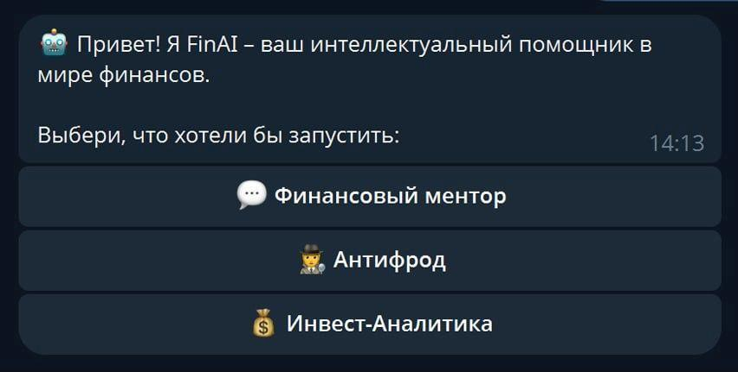

Social Benefits:
- Improved Financial Literacy: Users gain access to interactive courses, tips, and recommendations, which fosters responsible financial behavior.
- Reduction in Financial Fraud: The protector module analyzes suspicious messages and links, warning the user and thereby reducing cybercrime.
- Cultivation of a Financial Culture: The project promotes a responsible attitude towards money, savings, and investments, enhancing the overall financial stability of society.
- Creation of Opportunities for People with Special Needs: Through text-to-speech technology (e.g., ElevenLabs).

.Economic Benefits:
- Increased Investment Activity among Citizens: With transparent recommendations and education, users are more likely to engage with investment tools, boosting the circulation of national capital.
- Development of the Fintech Market and AI Industry: The project promotes the popularization of AI in applied financial solutions and stimulates the growth of domestic developers.

Technical Architecture (Brief):
- Frontend: Telegram bot with adaptive dialogues and interfaces (menus, buttons, notifications).
- Backend: Server-side API that interacts with the database and AI modules.
- AI Models: GPT or a local model.
- Text-to-Speech: ElevenLabs (for Kazakh, Russian, English).
- API Connection
- Database: SQLite (for testing).
Unlike other messengers (e.g., WhatsApp), Telegram provides an API, bots, cloud storage, and integration with external AI modules. This makes the project not just an application, but a part of the growing artificial intelligence infrastructure of the future. This is why this format was chosen: interactive learning + intelligent analysis + data protection. Furthermore, Telegram is an ideal platform for implementation—it is a flexible, secure, and promising ecosystem.

CONCLUSION
The "Financial AI: Your Mentor & Analyst" project is a step towards a future where financial literacy, security, and investment opportunities are combined in a single tool. It aligns with national digitalization priorities, utilizes advanced artificial intelligence technologies, and supports strategic initiatives for the development of AI infrastructure in both Telegram and Kazakhstan.
The project is designed to scale in several directions:
- Adding support for Kazakh and English languages.
- Introducing voice interfaces.
- Integrating micro-lending and budget planning features.
In summary, this project is not just an application but an ecosystem for personal financial development, where every user can become smarter, wealthier, and more secure. It is solutions like these that will shape the digital future of our country—a future that is sustainable, secure, and human-centric.

