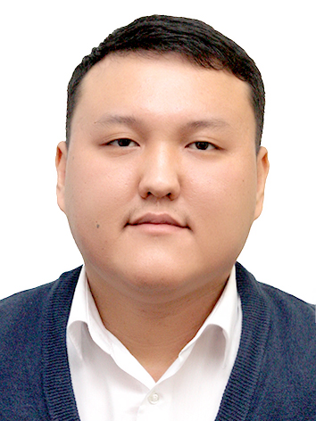 | Call number: 8(771)282-11-87,  e-mail: Ruslan.palimbet@mail.ru
Resume

Palymbetov Ruslan(03.06.1987)

Goal: Promising work in the organization, contributing to its prosperity, and realizing your capabilities.
Place of birth: Kyzylorda

Nationality: Kazakh
Marital status: Married with three children

Education: 2010-20122010-2012- Akmeshit Humanitarian and Technical Institute
Specialty - "Finance"
qualification-specialist in the field of financial organization
and institutions

2012-2014- Eurasian National University, Faculty of Physics and Technology
Specialty-Physics of Natural Sciences
qualification-Master of Natural Sciences

2018-2021-doctoral studies at the L. N. Gumilyov Eurasian National University of the International Department of Nuclear Physics, New Materials and Technologies, specialty" 6D060500 " - Nuclear Physics.
qualification is currently being defended
Work experience: from October 2008 to March 01, 2014.
Organization: RSE "Eurasian National University"
Position: Laboratory Engineer, International Department of Nuclear Physics, New Materials and Technologies
Responsibilities: -Preparation of the equipment of the laboratory for conducting laboratory classes;
- Conducting minutes of meetings of the department;
- Maintaining internal documentation of the faculty and department
2012-2014-Worked in the Admissions Committee of the L. N. Gumilyov Eurasian National University

from January 2015 to September 01, 2018
Organization: RSE "Eurasian National University"
Position: Senior Specialist of the Innovation and Patent Activities Department, Technology Commercialization Department
From August 26, 2022 to the present
Organization: «Kazakh University of Technology and Business
Position: Teacher, Department of Information Technology

Language proficiency: Kazakh-fluent, Russian-fluent, English-Intermediate

Additional Knowledge of computer programs at the level of a confident user.
Skills: vatel

Other qualities: Hard work, commitment, responsibility, ability to work in a team, easy training

Hobby: Football, music

