R E S U M E

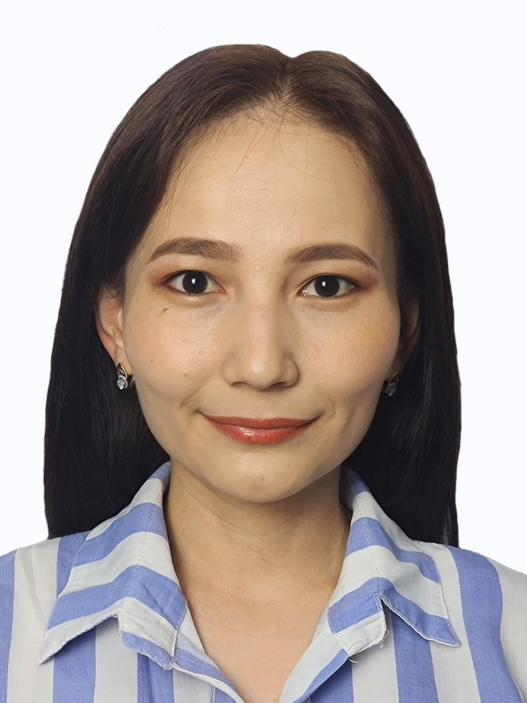 | Full name: Sabyr Aigerim Muratbekovna
 | Marital status: single
 | Mobile phone: 8 775 335 3114
 | Email address: aigerraa01@gmail.com
Education:
2013-2015 г.г. – Nazarbayev Intellectual School of Physics and Mathematics in Shymkent.
Higher. 2015-2019 – L.N. Gumilyov ENU, specialty "Information Systems".
Master's degree. 2019-2021 – L.N. Gumilyov ENU, specialty "Administrator for management and protection of computer systems and networks at enterprises".

Work experience, practice:
- June, 2018 – educational practice at the university;
- April-June, 2019 – internship at JSC "Kazhydromet" in the department of information technology
- 17.06.2019 — 06.09.2019 – passing an internship as a business analyst at Samruk-Energy JSC under the Digital Summer 2019 program
- 28.10.2020 — 01.02.2022 Manager at Kaspi Bank JSC
- 01.09.2022 — currently a lecturer at the University of KazUTB.

Publication:
- "Informatics and ontology". "Global Science and Innovations 2022: Central Asia" International Scientific and Practical Conference, 1 volume, Astana 2022, (24-27)

- "Application of the method and algorithm for the detection of pathology of the chest". "Proceedings of the National Academy of Sciences of the Republic of Kazakhstan Kazakh National Al-Farabi", CCSES, Astana 2022, (159-167)

