Resume

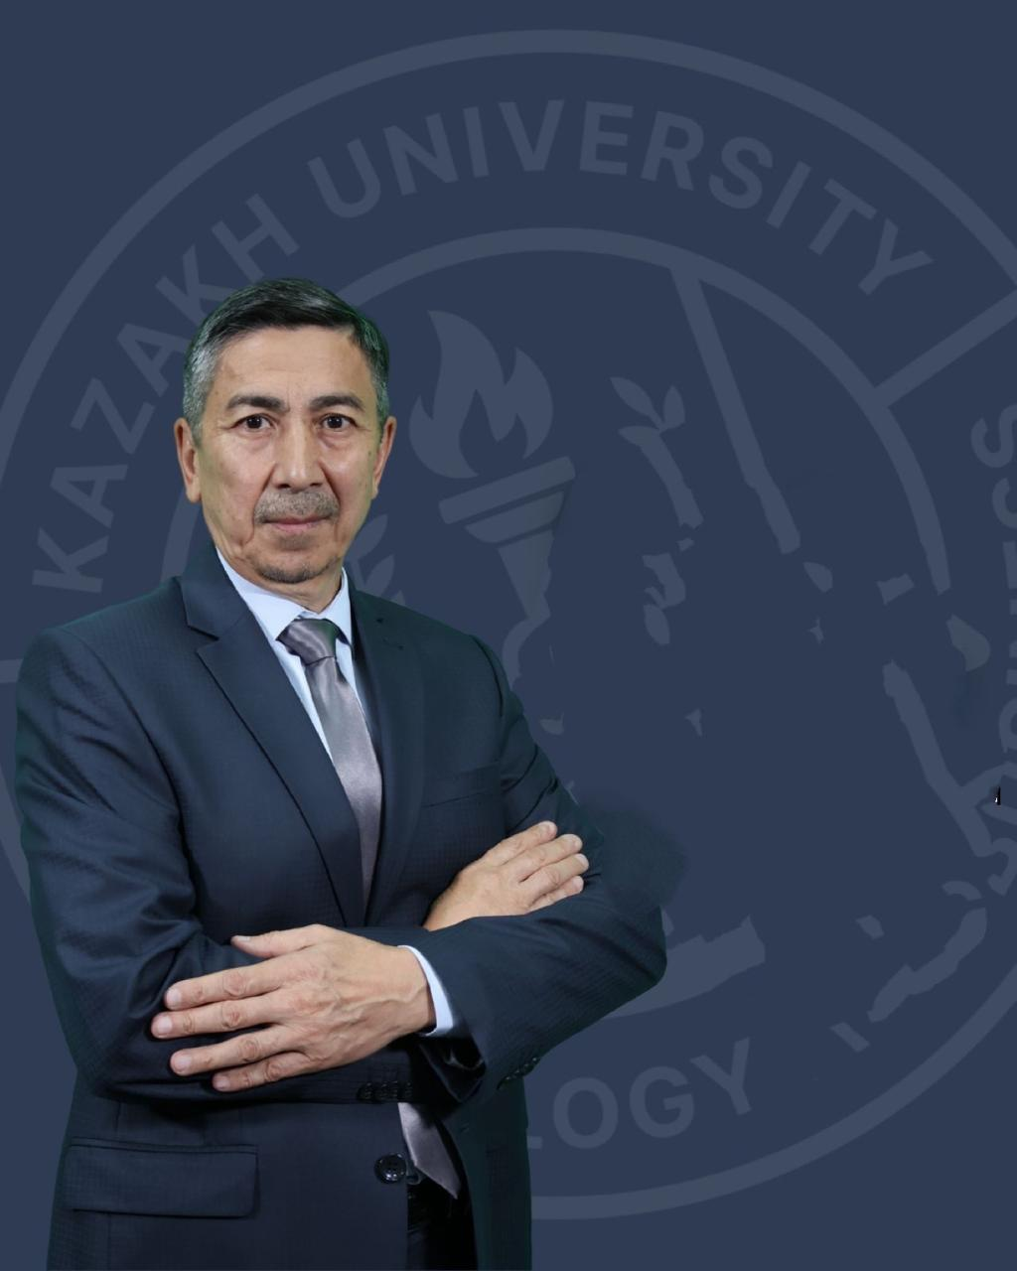 | Aikshev Karshyga Maksutovich
Job title | Head of the Department of Control and Automation
Education, qualifications | Higher education, Leningrad Polytechnic Institute named after M.I. Kalinin, mechanical engineer, specializing in "Robotic Production Technology".
Academic degree/title | Candidate of Technical Sciences (automation of technological processes and production - 05.13.06, Associate Professor (Associate Professor) (electrical engineering, electronics, information technology)
Publications
Number of publications in journals with non-zero impact factor over the past 5 years | - Digital transformation of production processes of enterprises for the production of construction products . NEWS of the National Academy of Sciences of the Republic of Kazakhstan SERIES OF GEOLOGY AND TECHNICAL SCIENCES ISSN 2224–5278 Volume 2. Number 470 (2025), 6–20. https://doi.org/10.32014/2025.2518-170X.487  2)The use of simulation modeling in calculating the productivity of the technological system for the production of building products with fillers from man-made waste. NEWS of the National Academy of Sciences of the Republic of Kazakhstan. SERIES OF GEOLOGY AND TECHNICAL SCIENCES ISSN 2224–5278, Volume 4. Number 466 (2024), 22–32 https://doi.org/10.32014/2024.2518-170X.422,  3) Evaluation of the efficiency of the technological process for the production of building products with fillers from metallurgical slag . Metalurgija ., 2024, 63(2), pages 267–270, Q3, percentile 40. http://pubweb.carnet.hr/metalurg/arhiva/3278  4) Information technologies in the management of technological processes for the production of building products. Eastern-European Journal of Enterprise Technologies , 2024, 1(2(127)), pp, 66–73. Q3, percentile 37. https://doi.org/10.15587/1729-4061.2024.298480  5) Development of an intelligent system automating managerial decision-making using big data. Eastern-European Journal of Enterprise ., 2023, 6(3(126)), pages 27–35. https://doi.org/10.15587/1729-4061.2023.289395
Number of publications in KOKNVO journals over the past 5 years | - Using artificial intelligence for monitoring unauthorized connections to consumer power networks . Toraygyrov University Khabarshysy. ISSN 2710-3420. Energetikalyk series, No. 2. 2025.  2) AUTOMATION OF SELECTION OF CONSTRUCTION MIX WITH ADDITIVES OF TECHNOGENIC RAW MATERIALS . BULLETIN OF KAZUTB, (section information, communication and chemical technologies), No. 1 (26), 2025.-P. 1-14. ISSN: 2708-4132.  https://doi.org/10.58805/kazutb.v.1.26-808  3) БІР ҚИЫЛЫСТАҒЫ БАҒДАРШАМДАРДЫ ЖДЫ ЖДЫ-ОБЪЭКТИВТІ ЖӘНЕ ЖДЕЛ АДАПТИВТІ БАСҚАРУ . International scientific and technical journal "Bulletin of the National Engineering Academy of the Republic of Kazakhstan", BULLETIN of the National Engineering Academy of the Republic of Kazakhstan No. 4 (94), 2024.-https://doi.org/10.47533/2024.1606-146X.005  4) . BULLETIN of KazUTB, (section information, communication and chemical technologies) No. 3 (24), 2024, pp. 96-104. ISSN:2708-4132.  https://doi.org/10.58805/kazutb.v.3.24-551  - EVALUATION OF THE EFFECTIVENESS OF USING THE SOFTWARE PRODUCT ”ASSISTANT FOR THE PREPARATION OF TEST TASKS” TO TEST THE KNOWLEDGE OF STUDENTS. KazUTB BULLETIN, (information, communication and chemical technologies section), No. 3 (24), 2024.-P. 13-26. ISSN: 2708-4132. https://doi.org/10.58805/kazutb.v.3.24-508  6) AUTOMATION OF LABOR PROTECTION SYSTEM MANAGEMENT AT AN INDUSTRIAL ENTERPRISE. Toraygyrov University Khabarshysy. ISSN 2710-3420. Energetikalyk series, No. 3. 2024, pp.31-51. https://vestnik-energy.tou.edu.kz/storage/journals/176.pdf  7) EVALUATION OF THE EFFICIENCY OF ADDITIVES OF METALLURGICAL SLAG WITH VARIOUS GRANULOMETRIC SIZES ON THE STRENGTH PROPERTIES OF CONSTRUCTION PRODUCTS. SCIENCE AND TECHNOLOGY OF KAZAKHSTAN. ISSN 2788-8770. No. 3, 2024. pp. 140-152. https://stk.tou.edu.kz/storage/journals/156.pdf
Monographs published over the last 5 years | 1) "Ecological and technosphere safety. Scientific and applied problems and solutions." Ecological and technosphere safety. Scientific and applied problems and solutions: monograph / edited by the scientific council of the State Research Institute "NatSrazvitie". - St. Petersburg: State Research Institute "NatSrazvitie", 2024. - 80 p. ISBN 978-5-00213-407-6 DOI 10.37539/240704.2024.56.58.001 https://disk.yandex.ru/d/FYg48SgsAvRx1A/2024/0704-Июль/МОНОГРАПФИИЯ  2) Engineering modeling of complex technological systems (production of building products using man-made waste). Publishing house "LantarBOOKS", Almaty, 2023. - 142 pages, 500 copies. ISBN 978-601-361-254-6
Textbooks and teaching aids for the last 5 years | - Pneumatic mashinalar men jetekter.Okulyk. Publishing house Lantar VOK, Almaty, 2024.-217b. ISBN 978-601-7207-49-6  - Hydraulics are not hydraulic machines. Okulyk. Publishing house Lantar VOK, Almaty, 2024.-212b. ISBN 978-601-7611-44-6  - Avtomattandyrylgan zhuyelerdi zhobalau. Oku kuraly.. Publishing house ADAL_Kitap, Almaty, 2024.-336b. ISBN 978-6017154-04-2  - Zhanartylgan energy kozderin avtomattandyru zhane baskaru zhuyelri.Oku kuraly.Izd.Adal Kitapbaspasy, Almaty, 2024.-134b..ISBN 978-601-7681-86-9.  Automation and control systems for renewable energy sources. Published in Almaty: LLP "Lantar-Vooks", 2023. – 124 p. ISBN 978-601-361-493-9
Patents and copyright certificates | - Computer program "Database of Man-Made Deposits of the Republic of Kazakhstan." Certificate of entry of information into the state register of rights to objects protected by copyright No. 58880 dated May 29, 2025. Research Institute of Information Systems of the Republic of Kazakhstan.  - Computer program "Automated system for selecting building mixtures with additives from technogenic raw materials." Certificate of entry of information into the state register of rights to objects protected by copyright 2025, issue "7", No. 54313. Research Institute of Construction of the Republic of Kazakhstan.  3) Computer program "Automated software development tool  syllabus » Certificate of entry of information into the state register of rights to objects protected by copyright No. 51735 dated November 21, 2024. Research Institute of Intellectual Property of the Republic of Kazakhstan.  4) Computer program "Test Assignment Preparation Assistant". Certificate of entry of information into the state register of rights to objects protected by copyright No. 48275 dated July 10, 2024. Research Institute of Information Systems of the Republic of Kazakhstan.
Electronic textbooks | - Electronic copyright certificate on amendments to the state register of rights to objects protected by copyright. No. 43647 dated March 13, 2024. NIIS RK  - E-course "Practical Training in the MS SQL Server DBMS." E-course "Practical Training in the Microsoft SQL Server DBMS." Certificate of Entry of Information into the State Register of Copyrighted Objects No. 38940 dated September 7, 2023.  3)Elektrondykokulyk “Automatic machines baskar theoryson kazirgi aspectilery.” Certificate of entry of information into the state register of rights to objects protected by copyright. No. 31590. from January 5, 2023
Development of OP and syllabi for new disciplines
Name of the OP | 1)7М07188-Automation and control  2) 6B07133-Digital Energy
Item name | - SADT Methodology  - Academic writing  - Systems analysis in IT  - Methods of conducting scientific research  - Methods of mathematical and simulation modeling  - Software tools in automation control systems
Scientific work
Participation in funded projects
Name, funding amount, position | 1) Development of a 3D printer for printing metal products for the defense industry  2) Development of a hardware and software complex based on artificial intelligence technologies for managing the flotation process at mining and processing plants
Research and development work
Title, performers | " A digital twin of the product quality management system at all stages of mining and metallurgical production"
Awards, incentives | - Letter of thanks from the Ministry of Health and Military Affairs. 2022.  - Honorary Professor of KazUTB, 2023
Refresher courses
Subject, place, date, certificate number | 1) Almaty, 2024, 72 hours, LLC Corporation "Saiman" / " Automation of technological  complexes and production facilities”, certificate No. A-177U  2) Astana, 2025, 72 hours, Astana-ceramic LLC, “Modern trends in automated production management”, certificate No. 091
Subjects taught | Aspects and principles of scientific research.  Methodology for carrying out scientific work.  SADT Methodology  Methods of mathematical and simulation modeling

