Resume

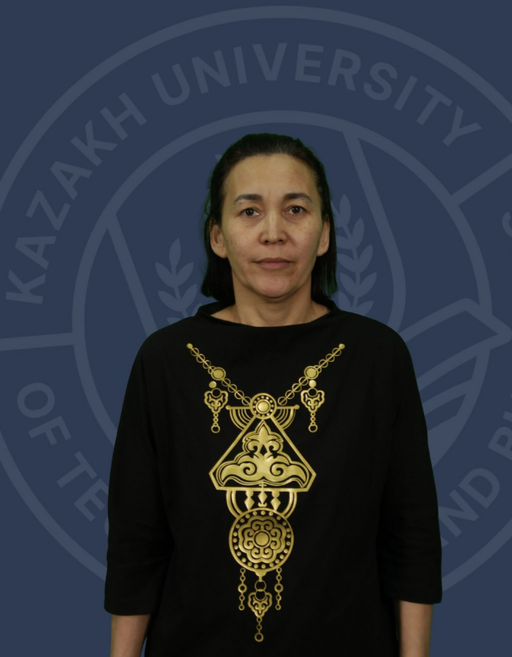 | Amangeldina Marzhan Amangeldinovna
Job title | Senior Lecturer
Education, qualifications | Higher [1995-2000] VKTU, Ust-Kamenogorsk; specialty: "Information systems".  Master's degree [2006-2008] D. Serikbaev East Kazakhstan State Technical University, specializing in "Automation and Control"
Academic degree/title
Publications
Number of publications in journals with non-zero impact factor over the past 5 years
Number of publications in KOKNVO journals over the past 5 years | 1. Optical Internet of Things. Bulletin of VKTU. – Ust-Kamenogorsk. 2020. – No. 2 (88). – P104-108. doi: 10.51885/15614212_2020_2_107  2. Organization of symbolic data transmission using white LED lighting. VKTU Bulletin. – Ust-Kamenogorsk. 2020. – No. 3 (89). – P. 65-69. doi: 10.51885/15614212_2020_3_69  3. Research of data transmission using computer-controlled LED lighting elements. Vestnik VKSTU. – Ust-Kamenogorsk. 2019 – No. 4. – P. 58-61
Monographs published over the last 5 years
Development of OP and syllabi for new disciplines
Name of the OP | 1) Automation and control
Item name | 1) vtomatt барқару theories  2) Ғылымы зерттеулердің негіздері  3) Automattandiru жүйелеріндегі controller бағдарламалау  4) Sheshim қабылдау theories  5) Avtomattandyrylgan жүйелердің жабдықтарын қорғау әдістері  6) Өнеркәсіптік electronics  7) IoT computer architectures
Refresher courses | 1) AI services are the secret weapon of a modern teacher 06.01-17.01.2025 Astana Almaty Technological University No. 0667  2) Inclusion of higher education: creating a comfortable educational environment for students with special educational needs from December 17 to December 30, 2024, No. 2164  3) Software and CAD for solving control problems. 5.02 to 11.03.2024 Astana, ISTOCK CHEMI LLP

