Resume
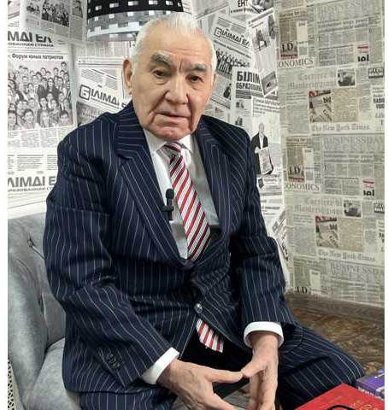 | Bektenov Latif Bektenovich
Job title | Professor
Education, qualifications | Higher
Academic degree/title | Doctor of Technical Sciences, Academician of the Russian Academy of Pedagogical Sciences.
Publications
Number of publications in journals with non-zero impact factor over the past 5 years | 18 articles, 2 textbooks, and 2 teaching aids on physics for technical universities and colleges, written by order of the Ministry of Education and Science, have been published.
Number of publications in KOKNVO journals over the past 5 years
Monographs published over the last 5 years
Textbooks and teaching aids for the last 5 years
Patents and copyright certificates
Electronic textbooks
Development of OP and syllabi for new disciplines
Name of the OP
Item name
Scientific work
Participation in funded projects
Name, funding amount, position | -
Research and development work
Title, performers
Startup project
Title, performers
Project commissioned by enterprises
Title, performers
Awards, incentives | Breast badge.
Refresher courses
Subject, place, date, No. certificate | In the past and current academic years, he has received two certificates of advanced training.
Subjects taught​ | 1) Physics (in Kazakh)  2)Akparattyk tegnologiyanyn physics and non-physics

