Resume

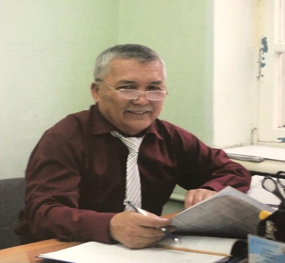 | Nurmagambetov Mereke Shaizadievich
Job title | Acting Professor of the Department of Computer and Automation
Education , qualifications | 1970-1975 – Ural Pedagogical Institute named after. A.S. Pushkin Uralsk , specialty: Physics and Mathematics Faculty. Qualification: Physics Teacher
Scientist degree / title | 1980-1983 – Postgraduate study at the Agrophysical Research Institute, Leningrad  In 1991 , he defended his candidate's dissertation in specialty 06.03.01 "Agrosoil science and agrophysics" on the topic " Study of hydrophysical properties of natural and modified swelling soils in connection with their melioration" AFI Leningrad
Publications
Number of publications in journals with non-zero impact factor over the past 5 years
Number of publications in KOKNVO journals over the past 5 years
Monographs published over the last 5 years
Textbooks and teaching aids for the last 5 years | - Electr t i zbekter theories .  Zertkhanalyk Zhumystar zhinagy Oku- adistemelik kural tekhnikalyk mamandyktarynyn students of our laboratory zhumys oryndauga arnalgan  Almaty, Daryn, 2023
Patents and copyrights evidence
Electronic textbooks
Development of OP and syllabi for new disciplines
Name of the OP | 1)7М07188-Automation and control  2) 6B07133-Digital Energy  3)6B06114-Information technology
Name subject | 1. Physics 2. Physics and physical foundations of information technology 3. Theory of electrical circuits and circuit design. 4. Theoretical foundations of electrical engineering.
Scientific Job
Participation in funded projects
Name , volume financing , position | 1) Development of a 3D printer for printing metal products for the defense industry
Research and development work
Title , performers
Awards , incentives | - “B іl іm zhаne ғylym қызметкеррерлінін кәсіpodагѓына сініргорень ензегі ушін” belgіsіmen marapattaldy Kualik No. 1189, 04/22/2022
Courses increases qualifications | 06/07/2021-06/19/2021 at the Scientific and Methodological Center " ZIAT " Application of innovative technologies in teaching the discipline " Theory of electrical circuits and circuit design ", 72 hours;  - 07/05/2021-07/17/2021 at the Scientific and Methodological Center " ZIAT " Application of innovative technologies in teaching the discipline " Equipment for automatic control, registration and accounting", 72 hours;  - 19.07.2021-31.07.2021​ at the Scientific and Methodological Center " ZIAT " Application of innovative technologies in teaching the discipline " Physics for students of technical specialties", 72 hours;  -10.10.2022-22.10.2022 at the Scientific and Methodological Center " ZIAT " Innovative approaches and methods of teaching the discipline " IT competencies and methods of online learning", 72 hours;
Subject , place , date , certificate number
Taught objects | Physics, Physics and physical foundations of information technology, Theory of electrical circuits and circuit design, Theoretical foundations of electrical engineering.

